The Macbeth Web Quest

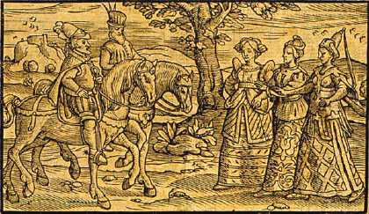

In order to complement our study of “Macbeth”, we will be exploring the life and times of William Shakespeare, as well as looking into the historical background of the play.

The task

Go through the various topics, reading carefully the information contained in the web links. Take notes as you go along, as there will be a quiz on the information covered in this research process.

1. Shakespeare’s life and times

- What do we know about Shakespeare as a man? What are some important biographical details that we need to be aware of?
- What was life like in his time? What was the society he lived in?

http://internetshakespeare.uvic.ca/Library/SLT/life/lifesubj.html
https://www.folger.edu/shakespeare

2. Shakespeare’s theatre

- What did theatre look and work like in Shakespeare’s time?
- What do we know about acting, costumes and audiences in Shakespeare’s time?
- What do we know about Shakespeare as a theatre man?
- Be sure to take an interactive tour of Shakespeare’s Globe.

http://www.bardweb.net/globe.html
http://www.enotes.com/william-shakespeare/shakespeares-globe-theater

3. King James

King James was the king at the time that Shakespeare wrote and performed “Macbeth”.

- How did James become king?
- What was he like as a king?
- What was the political climate in England at the time?
- How was James connected to “Macbeth”?

http://internetshakespeare.uvic.ca/Library/SLT/history/jamessubj.html

4. Witchcraft

Christianity continued to dominate people’s lives in the Renaissance period. People regarded witchcraft as the work of the Devil. They often went on witch hunts which resulted in the deaths of many people, especially women.

- How was King James connected to the campaign against witches and witchcraft?

http://internetshakespeare.uvic.ca/Library/SLT/ideas/witches.html

5. The Real Macbeth
- Was there a “real” person named Macbeth? What did Shakespeare use as his inspiration for writing this play?
- What was Shakespeare’s historical source for “Macbeth”?

http://www.pathguy.com/macbeth.htm

6. The Macbeth Curse

Over the years, people have reported suffering misfortunes, injuries and deaths after being associated with this play. Some assert that the play is cursed.

- Why do people think the play is cursed?
- Where did this idea originate?
http://www.austinchronicle.com/gyrobase/Issue/story?oid=oid%3A78882

